**API GATEWAY**

We will learn how to create API gateway and using that API gateway for lambda function. Here are the steps for creating it.

1. Search and go to API gateway.

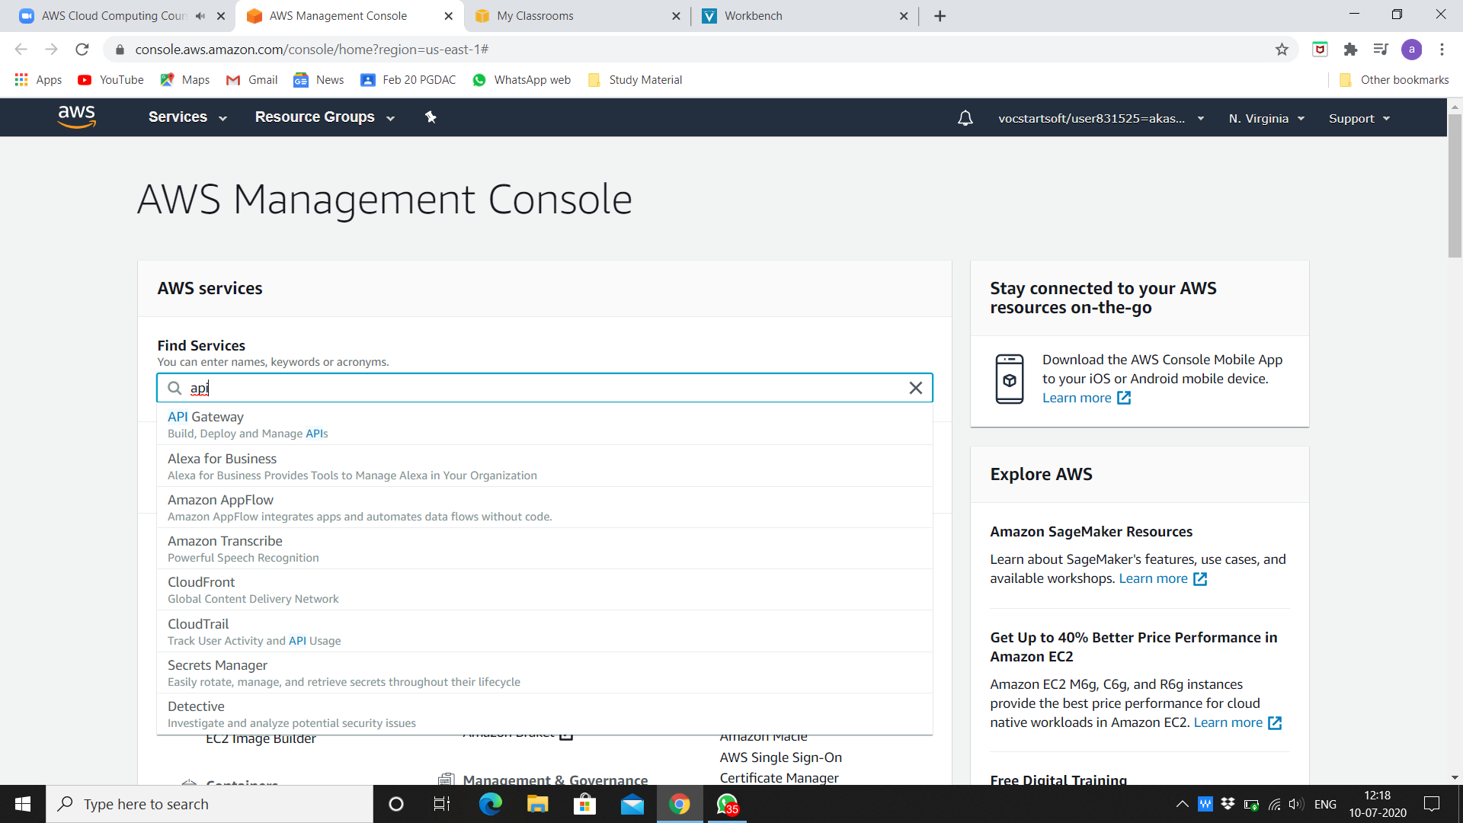

1. Choose REST API Public and click on build.

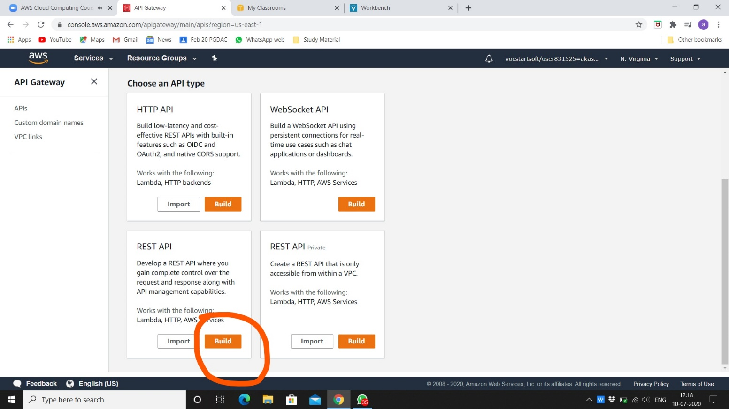

1. Click on okay for creating new API.

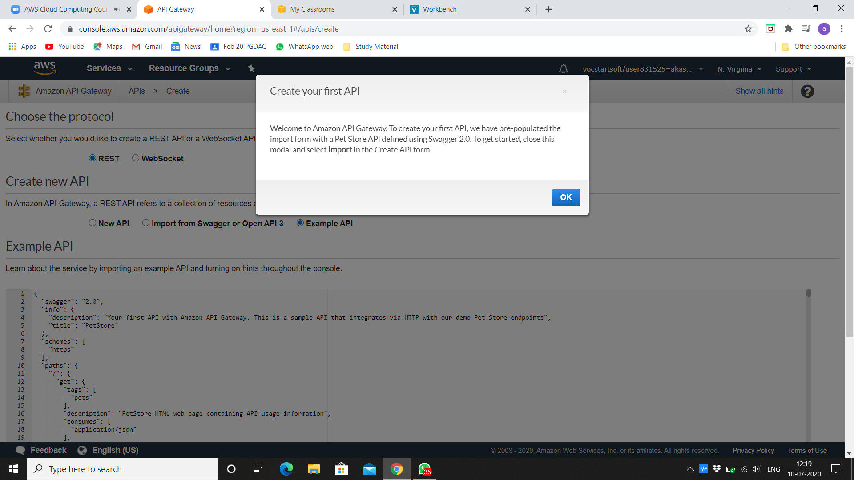

1. Choose the protocol REST. In create new API mark on new API, give name and description and keep Endpoint Type as regional.

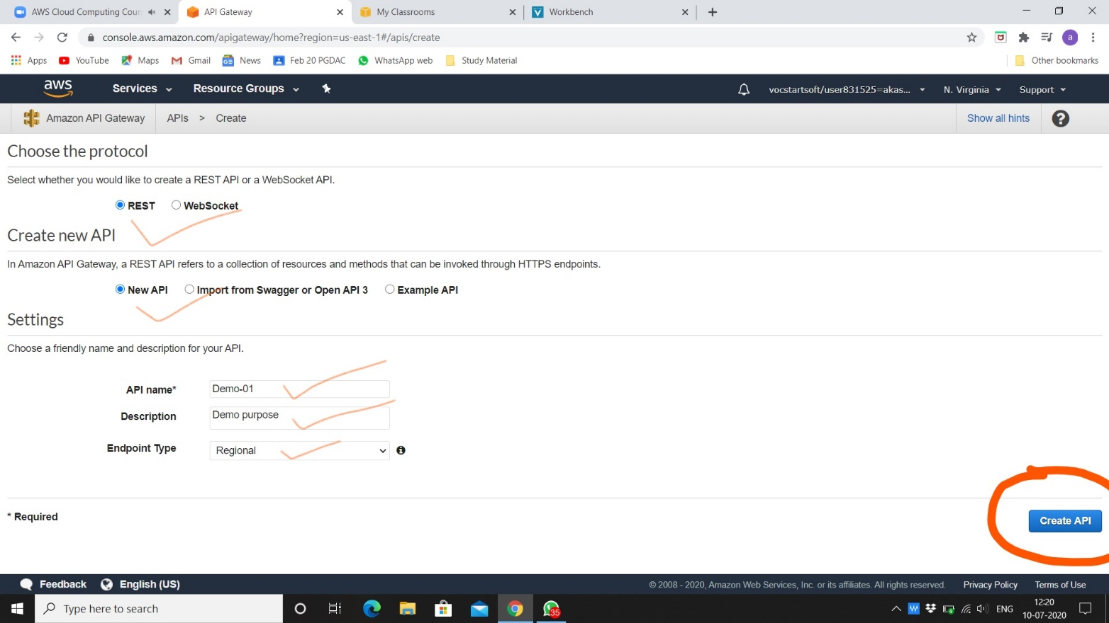

1. Go to actions and create new method.

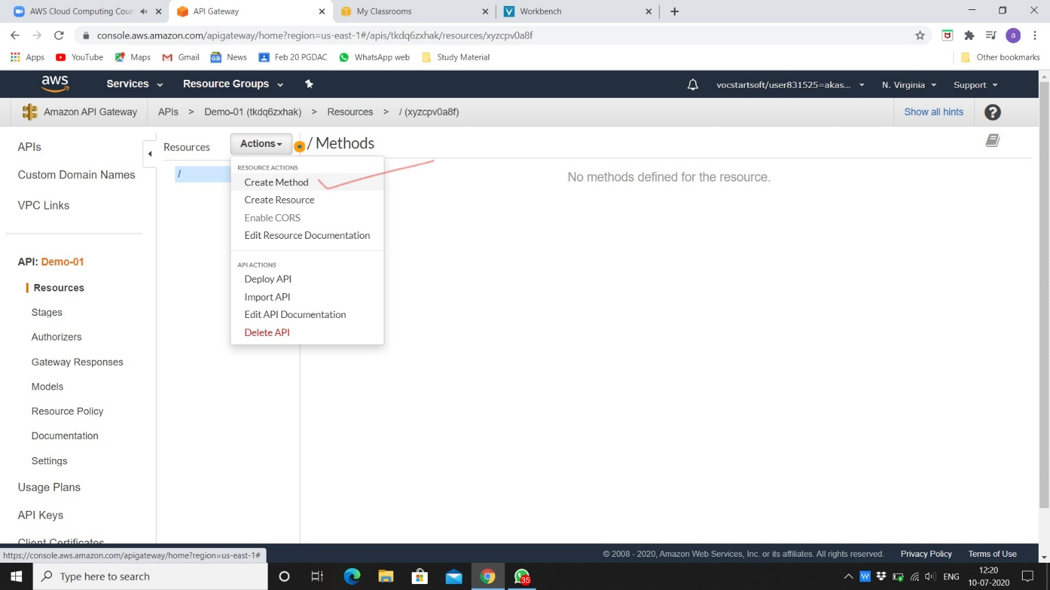

1. Click mark on given option.

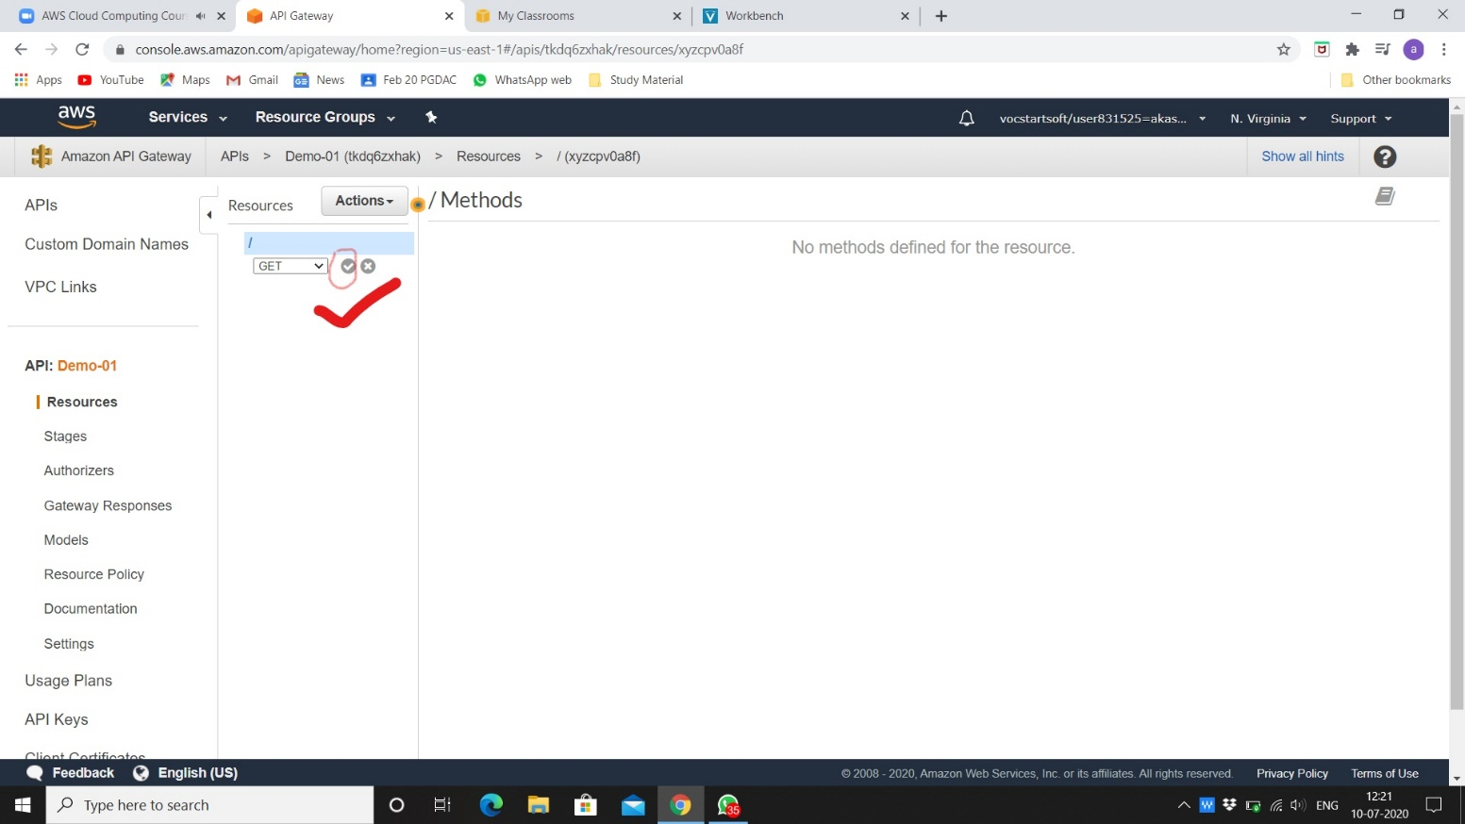

1. Do GET setup like below and give name of lambda fun and save it.

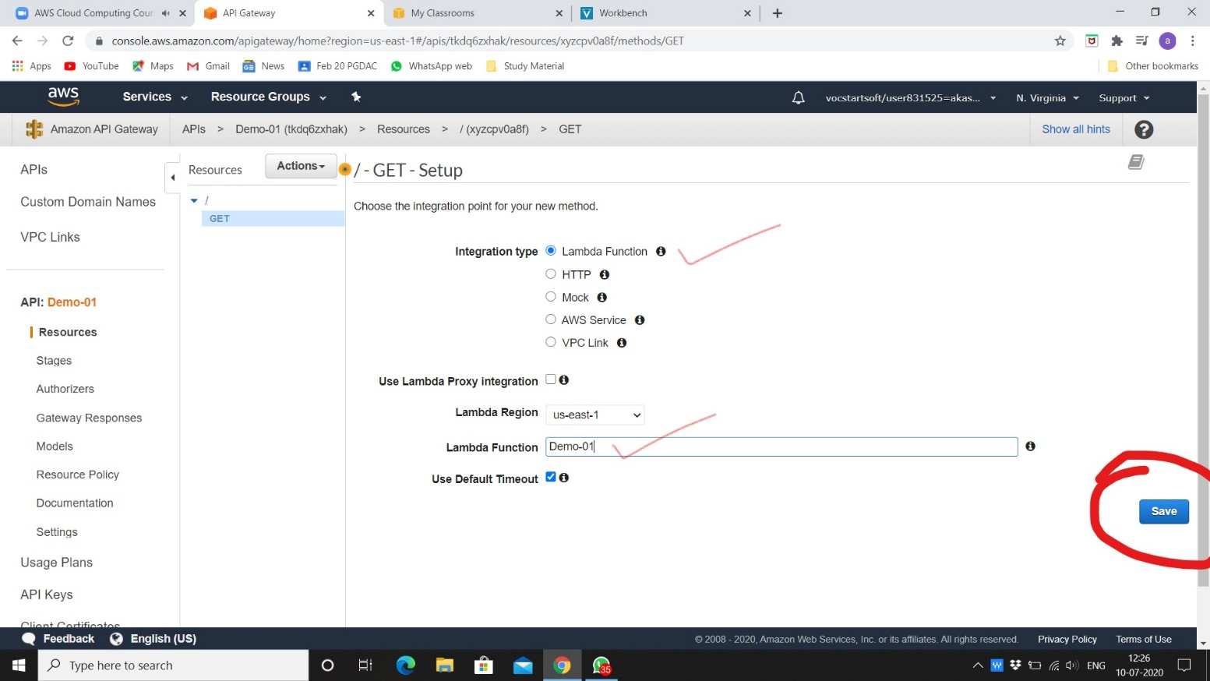

1. Click on ok for adding permission to lambda function.

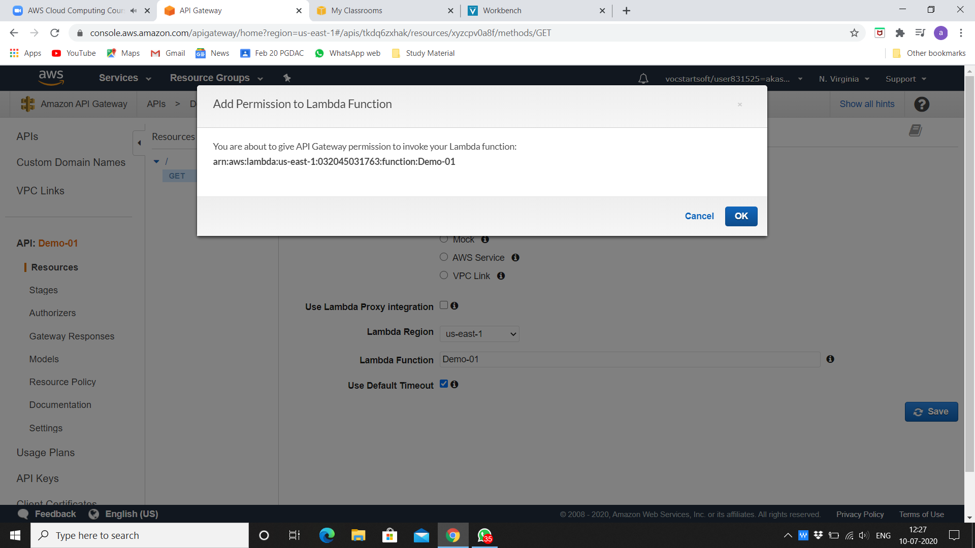

1. You can test after done with GET function like this.

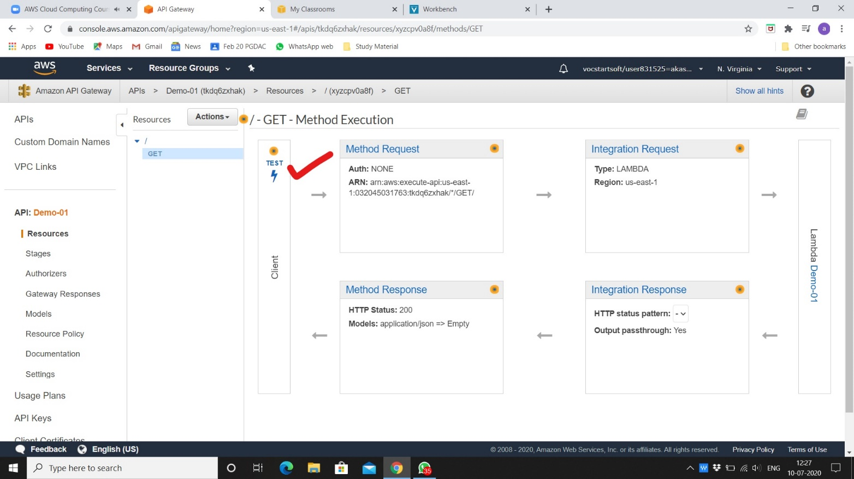

1. Click on test.

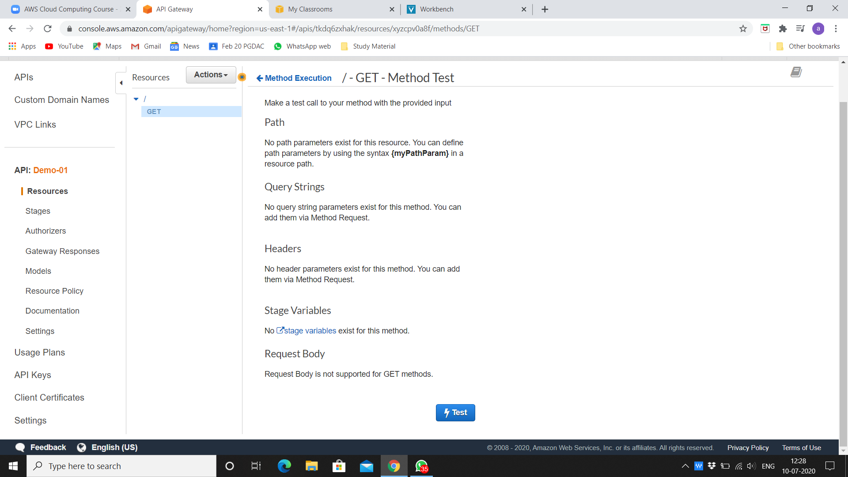

1. Here is the response message from lambda function.

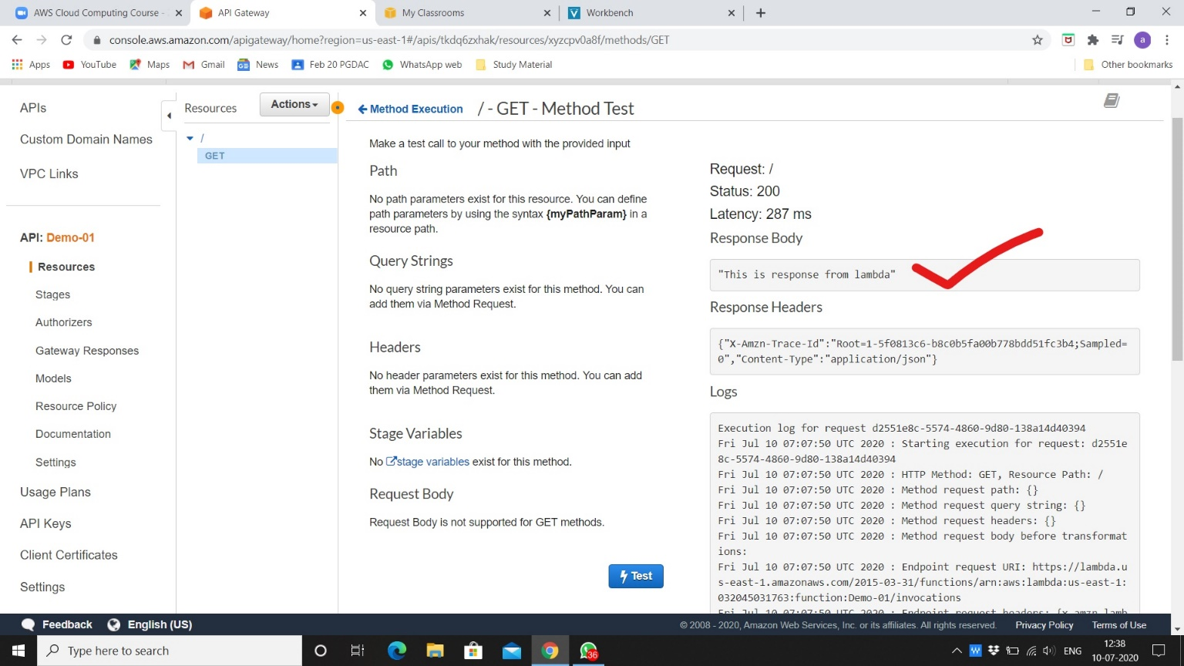

1. We can deploy API on browser also doing like this.

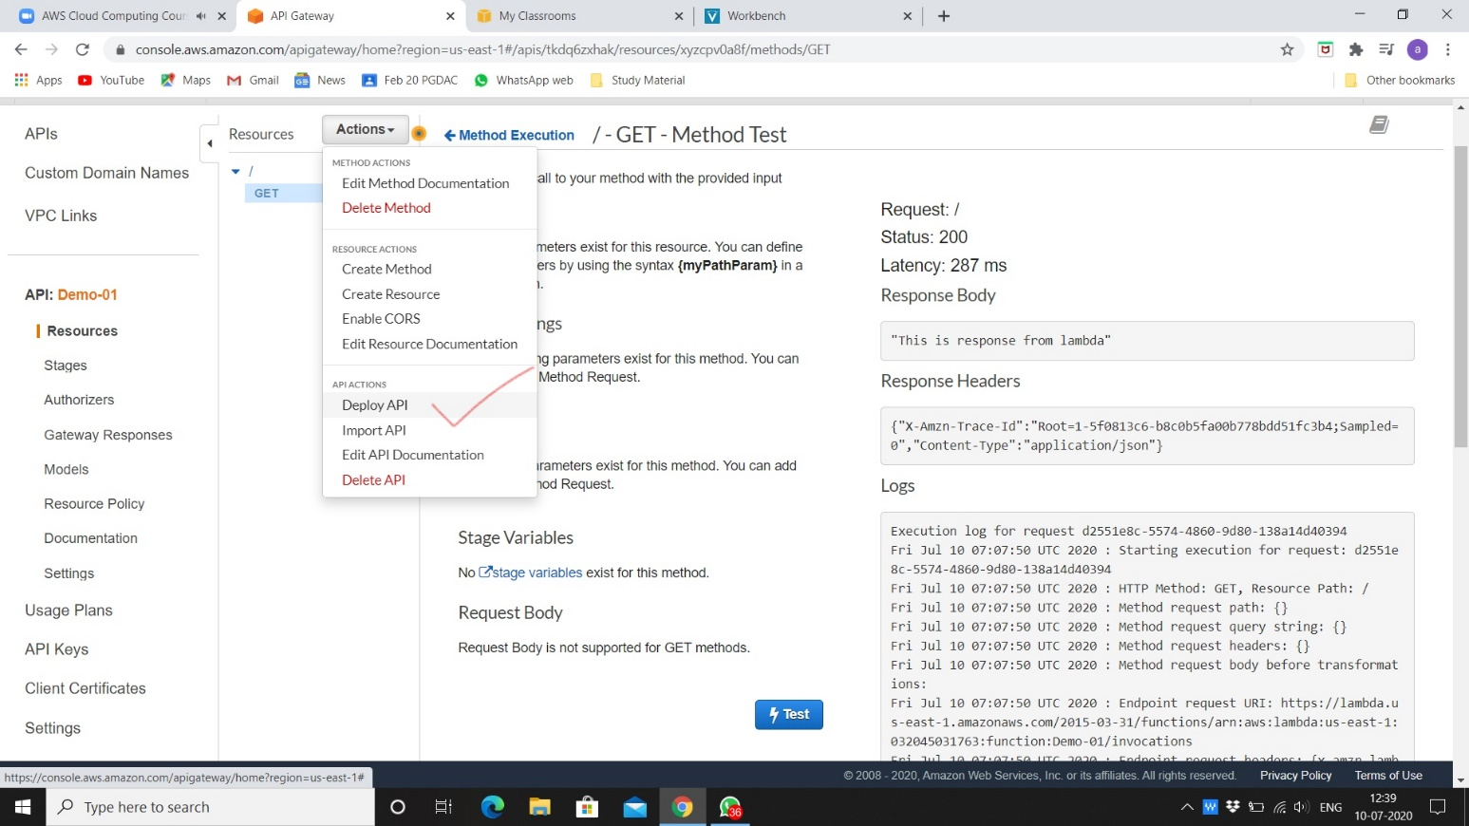

1. Give stage name and click on deploy.

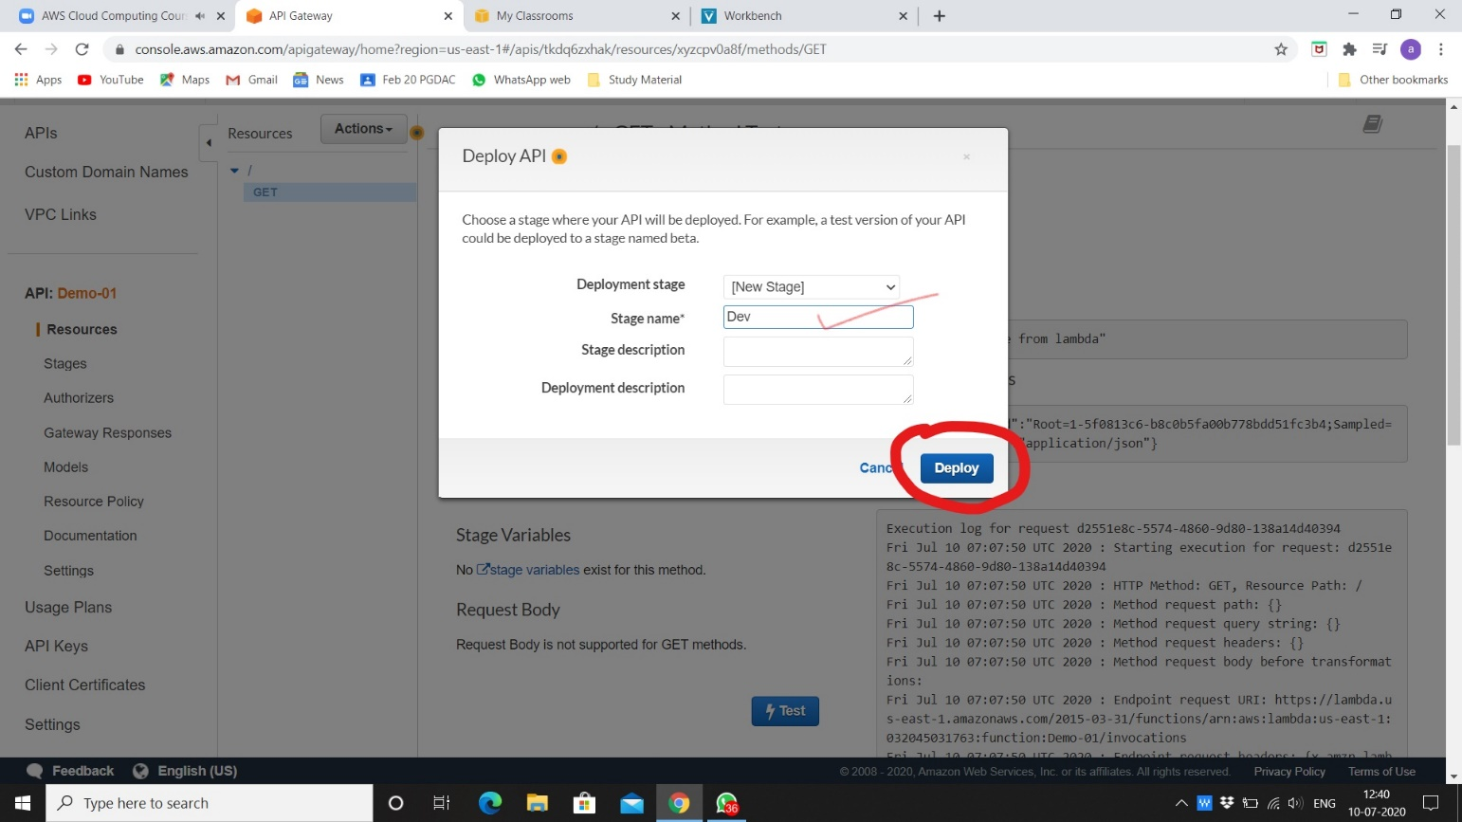

1. We can see response message from lambda function on browser.

